SVGC Creekside Presents
An Evening of Acoustic Music
Featuring
Local Singer-Songwriter
Dave Schaper
Friday, June 17, 2022
5PM – 8PM
Friday is prime rib night at SVGC
(Or order other selections from their fine menu)
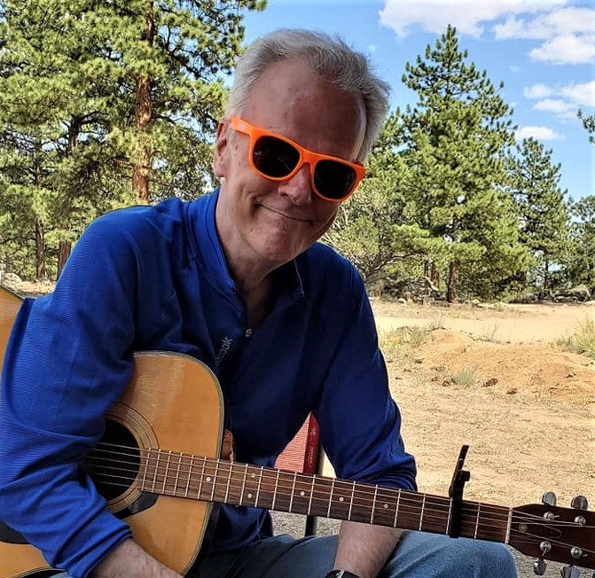

Spring Valley Golf Course
42350 County Road 17/21
Elizabeth, CO. 80107
(303) 646-4240

